This picture 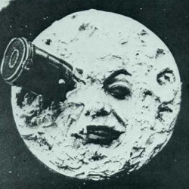 is an identicon.
Here is one that links.

